**HSC TRANSFORMATION UPDATE**

**MAY 2018**

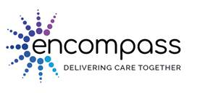The encompass Programme will introduce a digital integrated health and care record to Northern Ireland. It will mean a patients’ health and care information will be available to those who need it in one digital record, and as individuals we will be able to securely access our information and interact with the system. The encompass Programme has been approved by the Department to commence procurement, which is likely to start in the coming weeks.

|  |
| --- |
| ***Dr Michael Quinn*, encompass’ Clinical Director**, explains further in this [short video](https://vimeo.com/272551101) |

The programme’s Senior Responsible Owner is Dr Michael McBride (Chief Medical Officer) and the Transformation Implementation Group (TIG) keep a close interest on progress recognising that it will be hugely important in our transformation journey.

***Richard Pengelly* (Chair of TIG)** commented**,**

*“The encompass Programme offers us a unique opportunity to truly transform the way we care for people. It will also empower and support colleagues across the service in both delivering care, and driving innovation and transformation.*

*The engagement and support of staff and service users will be crucial in shaping its progress and its success. Working as one system, we will need to pull together in an unprecedented way in order to deliver encompass, enabling us to improve health outcomes and create better experiences for those receiving, using and delivering services”*

**What encompass will deliver at a glance**

|  |
| --- |
| * Information will be entered only once * Remove need for bulky paper patient notes * Data on mobile devices * Patients able to access their own record to enhance autonomy of care * New channels of communication between staff and patients * Standardise, measure and improve use of data * Evidence based and outcomes focused care |

**When will it Happen**

|  |
| --- |
| The aim is to begin implementation in 2020/21. |

***Further information*** *on the encompass Programme can be found from the* [*HSC Board website*](mailto:HSC Board%20website) *or by contacting the Team at* [*encompass@hscni.net*](mailto:encompass@hscni.net)*.*

**Transformation Highlights**

More ***transformation highlights*** since our last update are available below:

1. HSC Workforce Strategy
2. Transformation Funding
3. Elective Care Centres
4. TIG at NICON18
5. Transforming Cancer Services
6. Looked After Children
7. Social Procurement Clauses

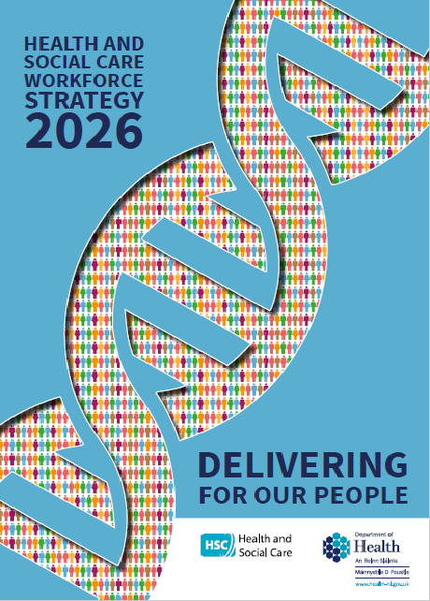**HSC Workforce Strategy 2026**

The [Health and Social Care Workforce Strategy 2026: Delivering for our People](https://www.health-ni.gov.uk/publications/health-and-social-care-workforce-strategy-2026) was published on 14 May 2018. The Strategy was developed by the Department, HSC bodies and health and social care providers in close co-operation with trade unions and other organisations. The Department is committed to further close and co-operative working to implement the actions.

At the heart of the strategy is the stated aim that by 2026, we meet our workforce needs, and the needs of our workforce – both equally important. Its vision is for health and social care to be a rewarding and fulfilling place to work for everyone, with the best possible staffing and expertise levels in place.

The 10 year strategy is designed to provide a long term approach which can take account of changes and improvements to health and social care over its life. The first action plan runs to 31 December 2020 and contains 24 specific actions, and includes setting up and rolling out a regional HSC careers service aimed not only at the existing workforce but also young people from 14 upwards and possible returners to service.

An initial allocation of £15m in workforce development, from the £100m transformation fund for 2018/19, has also been announced. Around a third of the £15m will be directed towards nursing, midwifery and allied health professional workforce. As part of a broad range of training investment, this includes 74 additional pre-registration nursing places and 25 additional midwifery places, taking the total training places for nursing and midwifery to 1000 in 2018/19 – an all time high for Northern Ireland.

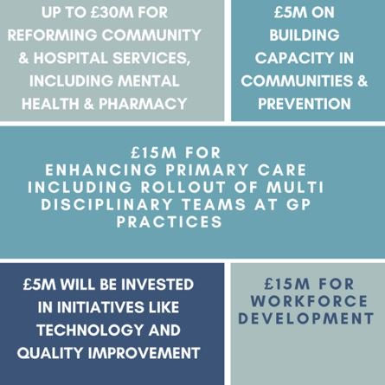**Transformation Funding**

Earlier this month the Department released further details of how the £100m HSC Transformation Fund would be spent. The £15m for enhancing primary care includes funding to enable the roll-out of multi-disciplinary teams this year in two areas initially, each serving in the region of 100,000 people.

We have already mentioned the £15m for workforce development above. A further £30m has been announced for reforming community and hospital services such as cancer, stroke, paediatric services and diabetes care and prevention, and implementing transformative change through initiatives like introducing elective care centres and medicines optimisation.

In addition to this, £5m will be invested in a range of targeted actions aimed at strengthening the voice of those who use and those who deliver HSC services, with another £5m to build capacity for system wide quality improvement through investments in technology and supporting innovation.

In March this year, the [Department announced](https://www.health-ni.gov.uk/news/health-announces-ps30m-tackle-hospital-waiting-lists) that £30m of the transformation fund money would be targeted at waiting times, in working towards achieving stabilisation of current hospital waiting lists.

[](http://www.westerntrust.hscni.net/about/1622.htm)**Elective Care Centres**

***Teresa Molloy,*** Director of Performance and Service Improvement (Western Health and Social Care Trust) and ***Raymond Curran***, Head of Optometry (Health and Social Care Board) have been appointed as Chairs to the Task and Finish Groups to lead work on elective care centres for varicose veins and cataract surgery. Both groups will be co-chaired by clinical leads.

Members will be selected to reflect a range of relevant knowledge, skill and experience from across the HSC system and will also include service users. This will be kept under review to enable the groups to draw on expert advice/critical friends as required. It is expected that the two prototypes will be ready for implementation by the end of the year.

**TIG at NICON18**

The NICON 2018 conference was held over 2 days on 17/18 April 2018, and ***Delivering Together*** was the theme of this year’s conference. The event annually brings together delegates from the HSC alongside speakers, exhibitors, sponsors, colleagues from other sectors and visiting experts.



***Richard Pengelly***, DoH Permanent Secretary and Chair of TIG gave the [opening keynote address](https://www.health-ni.gov.uk/articles/key-transformation-priorities-nicon-2018-conference) and a panel of ***TIG members*** spent an hour answering questions and sharing their personal reflections on the transformation process, as well as meeting delegates over lunch.

This was particularly well received by attendees and visibly served to illustrate how senior system leaders are working together in practice. ***Sharon Gallagher***,the Department’s Director of Transformation, also provided a progress update on [Key Transformation Priorities.](https://www.health-ni.gov.uk/publications/update-key-transformation-priorities-april-2018)

|  |
| --- |
| The slide presentations from NICON18 are available on their [website](http://www.nhsconfed.org/events/2018/04/nicon-18). |

**Transforming Cancer Services**

## In February 2018, the Transformation Implementation Group (TIG) approved the establishment of a Cancer Services Workstream to lead on the “*development of a sustainable model to support the delivery of regional cancer services, with an initial focus on providing high quality stable and sustainable non-surgical oncology services which will include chemotherapy and radiotherapy”****.***

The remaining phases of the project are:

|  |  |
| --- | --- |
| **Key Stage** | |
| **Phases 2 & 3 Scope, Plan & Design** | |
| Progress update to TIG | 4th July 2018 |
| Draft Interim Report to TIG | 28th August 2018 |
| **Phase 4 Finalise Recommendations** | |
| Development of a workforce plan, recommended model and investment & implementation plan for service transformation | Sept 2018– May 2019 |

***Hugh McCaughey***, Chief Executive of the South Eastern Health & Social Care Trust and Chair of NICaN will be the Senior Responsible Owner for the programme.

**Looked After Children**

Together with the Department of Education, the Department has launched a [public consultation](https://www.health-ni.gov.uk/consultations/looked-after-children-strategy-consultation) on a draft strategy for Looked After Children, ***Improving Children’s Lives*.**  The joint strategy was developed with the input of key stakeholders, including children and young people who are care-experienced. It aims to improve the well-being of looked after children in key areas of their lives.

[*Health and Wellbeing 2026: Delivering Together*](https://www.health-ni.gov.uk/sites/default/files/publications/health/health-and-wellbeing-2026-delivering-together.pdf)recognised the Department’s corporate parenting responsibilities and committed to honour these to the fullest extent through being as ambitious for children in care as for our own children.

The public consultation will close on **4 July 2018** and 5 workshops will be jointly hosted by both Departments across Northern Ireland.

Listen to ***Sean Holland*,** the Department’s Chief Social Worker explain the process in more detail [**here**](https://www.youtube.com/watch?v=6F8dfLadXdo&feature=youtu.be)**.**

**Social Procurement Clauses**

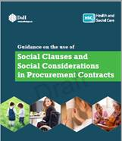

The [Guidance on the Use of Social Clauses and Social Considerations](https://www.health-ni.gov.uk/publications/social-clauses-and-social-considerations-procurement-contracts) in Procurement Contracts was launched on 10 May 2018.

The new guidance was developed with stakeholders from the community and voluntary sector, policy leads and HSC organisations. It will assist HSC staff involved in procurement decisions to understand how social clauses can contribute to wider societal goals, maximise the benefits of the expenditure being undertaken and underpin the delivery of health and wellbeing to the population of Northern Ireland.