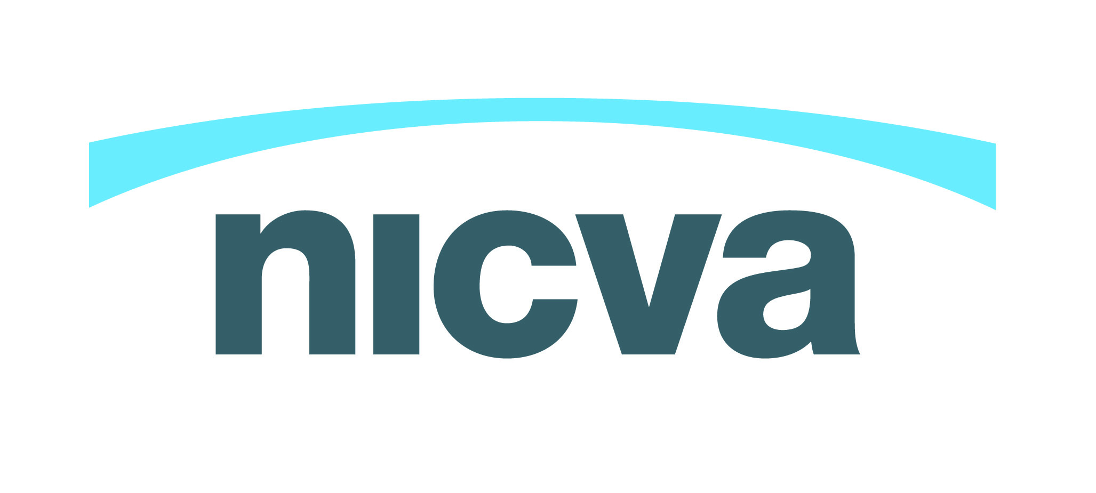

Funding Change - Scoping Paper One
There are three main types of funding available; grants, grant in aid, and procurement. This paper looks at each of them and outlines when it is appropriate to use them and the differences between them.
The information in this document is based on advice from HM treasury and the National Audit Office.
- Grants

The National Audit Office states; ‘Grants are used to fund an activity of a recipient because that activity is in broad alignment with the government’s objectives. There is a continuum of uses of grant, although grants in general are subject to a more detailed level of control than grant-in-aid.’

How are grants used?

Grants are where the grant-giving body (or ‘funder’) offers funding for specified activities, usually following an application process. The recipient must use the grant for the purposes specified and the money is restricted to these activities only. Grants are, therefore, different to donations as donations are normally unrestricted.

Grants offer the opportunity to undertake activity that cannot generate enough income to cover its costs. They are ideal for supporting research and development, building capacity or for new activities which over time could become self-financing. Grants are also widely used for specific projects and to cover the core operating costs of voluntary and community organisations such as salaries and overheads.

Grant challenges
- Short-term nature - if the activity is to continue after funding ends and it is funded through grants, there needs to be a plan for how it will be funded longer-term (also known as an exit strategy).
- Specifications - many funders have specific priorities for the types of activity they want to fund and this doesn’t always correspond with what organisations want to do.
- Oversubscribed funding - the total amount of grant funding received by the voluntary and community sector has fallen in recent years and is likely to fall further as a consequence of the economic climate. There are also more organisations and groups looking for funding which means greater competition.
- Organisation management - funders may have terms and conditions that require organisations to manage themselves in a particular way. For example, they may need to introduce additional financial procedures and systems.
- Time - each funder has their own criteria, priorities and processes, which means every application has to be tailored. Once the organisation has managed to submit their application form it takes time to get a decision – on average from two to six months depending on the individual funder and scale of grant requested.

When is it appropriate to use a grant?
‘Strategic funding’: supporting organisations that are of strategic importance in that they help achieve specific government objectives.
Compared with social investment or loan finance, delivering contracts or trading, grant funding is usually more accessible and manageable for smaller organisations.

- Grant in aid/Strategic Grant
The National Audit Office define Grant in Aid as ‘a payment by a public sector funder (normally referred to as the “sponsor department”) to finance all or part of the costs of the body in receipt of the grant-in-aid.’
Grant-in-aid is paid where the government has decided, subject to parliamentary controls, that the recipient body should operate at arm’s length. The recipient body will have activities which are in line with the government’s objectives and its relationship with government will be characterised by a high level of trust,.
Funding to a voluntary or community organisation given by way of grant-in-aid will be unrestricted funds for the organisation, because it supports the voluntary of community organisation’s overall activities, not any specific project. The voluntary or community organisation may commit to deliver certain outcomes or improved services to qualify for the funding, but with grant-in-aid the funder is not imposing restrictions on how the funds can be spent.
The decision whether to pay a grant or to provide grant-in-aid depends primarily on the level of detailed control which a department is required, or wishes, to exercise over the related expenditure. Grant payments are subject to a more detailed level of control than grants-in-aid. In practice, there is some overlap between the three funding channels.

Key differences between Grant and Grant in Aid
The National Audit Office states; ‘If you have decided to use grant as the basis for a financial relationship, you then have the further option of choosing to use ‘grant-in-aid’ (in central government) or ‘strategic grant’ (especially in local government and the NHS). The key differences are:
- A grant is used for financing a specific and agreed activity for a voluntary or community organisation. A grant-in-aid/strategic grant can also be used to help organisations carry out activities chosen within broad parameters agreed with the public body.
- A grant-in-aid/strategic grant is used when there is a high level of trust between the public body and the voluntary or community organisation. Often, the voluntary or community organisation carries out work that might be carried out directly by the Government in other countries similar to the UK. For example, grants-in-aid are used in central government to fund bodies such as national museums. At local level, strategic grants are often used to fund bodies such as Councils for Voluntary Service and Race Equality Councils.
- Under grant-in-aid, the management relationship between the voluntary or community organisation and the public body is deliberately at arm’s length. Typically, the public body gives a steer on its priorities once a year and monitoring and evaluation should be light touch. Accountability arrangements should emphasise the accountability of the trustees (or equivalent).
When is it appropriate to use grant in aid?
Development funding: developing a new organisation, or the capacity of an existing organisation, that will contribute to government objectives.

- Procurement
The National Audit Office define procurement as a process used to acquire goods, works or services in line with the government’s policy of value for money – “the optimum combination of whole-life cost and quality (or fitness for purpose) to meet the user’s requirement” – normally achieved through competition.

The term procurement covers the specific activities of buying services, from the initial advertising through to the final contract arrangements. It refers to the procedures public bodies must follow when they purchase services. The EU procurement process is just one of the routes open to public bodies when they are deciding what services to commission.

Procurement law is complex and procurement of contracts for services by public bodies must follow EU procurement regulations (if they apply) and general EU treaty principles.

When is it appropriate to use procurement?
Service/project financing: funding a particular service (on-going) or project (time limited) that will contribute to government objectives. Procurement will most often be appropriate in this mode.
How can you apply for procurement?
This is a list of Government procurement websites which offer opportunities to bid for contracts, delivering services and providing goods.

There are several websites to view procurement opportunities in Northern Ireland. These are generally from within the health, education, housing and transport sectors and from Roads Service and NI Water. These organisations have procurement expertise in their respective areas of responsibility:

- Central Procurement Directorate: https://e-sourcingni.bravosolution.co.uk/
- Northern Ireland Housing Executive: www.nihe.gov.uk/news/tenders/
- Northern Ireland Water: www.niwater.com/tenderopps.asp
- Department for Regional Development

- Current Tenders: www.drdni.gov.uk/index/procurement/contractadverts-current_tenders.htm
- Future Tenders: http://www.drdni.gov.uk/index/procurement/contractadverts-future_tenders.htm
- TED (Tenders Electronic Daily) EU: TED (Tenders Electronic Daily) is the online version of the 'Supplement to the Official Journal of the European Union', dedicated to European public procurement. ted.europa.eu
- E-Hub (small scale tenders often by local councils): www.e-hub.com/epublic/PublicTenderResults.asp
- Belfast City Council: www.belfastcity.gov.uk/tenders/all.asp

For further information on procurement, please follow the DFP guide which aims to help Social Economy Enterprises (SEEs) increase their knowledge and understanding of public sector procurement and in so doing, helps them to develop their capability to compete successfully for public sector contracts

http://www.dfpni.gov.uk/index/procurement-2/cpd/cpd-suppliers/guidance-note-01-11/pgn-01-11-04022013-guide-for-sees.pdf
Further references for financial assistance;
- NICVA aims to simplify funding for voluntary and community organisations through the Fundraising NI website which provides a list of opportunities, funding advice and support.

- NICVA has a website called Grant Tracker which is dedicated to finding grants for charities, clubs, community groups and other not-for-profits. To find out more visit www.granttracker.org

For further guidance on Grant in Aid, please follow the links below;
- https://www.gov.uk/government/uploads/system/uploads/attachment_data/file/80084/PublicBodiesGuide2006_7_planning_funding_0.pdf

- http://www.nao.org.uk/decision-support-toolkit/financial-relationships-with-third-sector-organisations-a-decision-support-tool-for-public-bodies-in-england/stage-2-strategic-decisions/choose-a-funding-channel/

http://www.nao.org.uk/decision-support-toolkit/financial-relationships-with-third-sector-organisations-a-decision-support-tool-for-public-bodies-in-england/stage-2-strategic-decisions/choose-a-funding-channel/
http://www.ncvo.org.uk/practical-support/funding/grants?highlight=WyJncmFudHMiXQ==
http://www.ncvo.org.uk/practical-support/funding/grants?highlight=WyJncmFudHMiXQ==
http://www.nao.org.uk/decision-support-toolkit/financial-relationships-with-third-sector-organisations-a-decision-support-tool-for-public-bodies-in-england/stage-2-strategic-decisions/choose-a-funding-channel/
http://www.nao.org.uk/decision-support-toolkit/financial-relationships-with-third-sector-organisations-a-decision-support-tool-for-public-bodies-in-england/stage-2-strategic-decisions/choose-a-funding-channel/
http://www.nao.org.uk/decision-support-toolkit/financial-relationships-with-third-sector-organisations-a-decision-support-tool-for-public-bodies-in-england/stage-2-strategic-decisions/choose-a-funding-channel/
http://www.nao.org.uk/decision-support-toolkit/financial-relationships-with-third-sector-organisations-a-decision-support-tool-for-public-bodies-in-england/stage-2-strategic-decisions/choose-a-funding-channel/
http://www.fundraisingni.org/tags/tags/procurement

